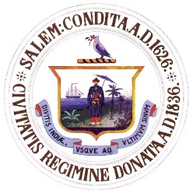
City of Salem, Massachusetts
Department of Open Space
Cemetery – Shade Tree – Open Space
57 Orne Street
Salem, Massachusetts 01970
SeAN Mc CrEA
asst. director of public services

Kimberley Driscoll
Mayor
Telephone: 978-745-0195
Fax: 978-741-7041

NOTICE

CEMETERY COMMISSION MEETING

TO Board of Cemetery Commissioners

Subject: Cemetery Commission Meeting and Agenda

A meeting of the Cemetery Commission is scheduled for Wednesday , August 30, 2017 at 6:30 pm. It will be held at 120 Washington Street, 3rd Floor, Salem Ma. in the medium conference room.

AGENDA

- Roll call of Board members
- Read minutes from last meeting
- Appointment of new Chairperson

Unfinished Business
Broad Street Cemetery – status of tree trimming and pruning
Cemetery Signage – status
Computer Status –update
Fountains – Final decision and vote
Doggie bags and barrels – completion
Greenlawn Cemetery Master Plan – progress and status
New Business
Vote taken on burial obligations
Cemetery projects to date (Anthony O’Donnell)

DOGS IN CEMETERIES
On Apri. 12, 2016, the Cemetery Commission voted to make NO DOGS ALLOWED in satellite cemeteries(Broad St., Essex St., and Howard St. cemeteries) a city ordinance. Ron was to go before Beth Rennard to find out what he needed to to next to go before the City Council to get the Ordinance. Ordinance was tabeled in City Council

