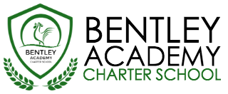
Bentley Academy Charter School
Will hold a Board Retreat on
Monday, January 11, 2016
9:00 am – 2:00 pm
Essex Meeting Room at the Hawthorne Hotel
18 Washington Square W
Salem, MA 01970
Board Retreat Agenda

9:00 to 9:15 | - Arrival, Ice Breaker & Agenda Setting
9:15 to 11:30 | - Governance Best Practice Training  - Topics to be covered:  - Best Practices of High-Performing Charter School Boards  - Other issues uncovered in self-assessment
11:30 to 12:00 | - Lunch Break
12:00 to 1:00 | - Action Planning and Goal Setting  - The Board will establish SMART goals for the next 12 months.  - Breakout groups will be charged with creating SMART goals for one of the following strategic areas of focus (30 minutes):  - Preliminary Areas of Focus:  - Academic Program  - Governance  - Finances  - Human Resources  - Collective reporting out and consensus on goals (30 minutes)
1:00 to 1:10 | - Break
1:10 to 1:50 | - Articulating the Mission  - Review and commitment to Mission  - Identification of Key Words/Phrases to describe Bentley  - “Friend Raising” Role Play
1:50 to 2:00 | - Wrap Up

