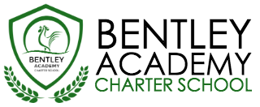
Bentley Academy Charter School
Board of Trustees Meeting
Wednesday, August 24, 2016
6:00pm
At the Bentley School
25 Memorial Drive, Salem MA 01970

Mission: Bentley Academy Charter School prepares all of its students for personal and academic success to get to and through college. Through a combination of high academic standards, data-derived instructional methods, and community supports and partnerships, Bentley Academy Charter School establishes the critical foundation necessary for students to thrive as they advance in their academic careers.

6:00 | - Call to Order
6:00-6:05 | - Approval of Minutes (Action Required)
6:05-6:30 | - Chair Update  - Academic Update and Head of School Update
6:30-7:00 | - Communications guidelines and policy (action required)  - Special guest Jennifer Flagg
7:00-7:15 | - Accountability Plan Amendment (action required)
7:15-7:30 | - Trustee election (action required)  - Two candidates – see separate letters of interest/resumes
7:30-7:40 | - Trustee Officer Election – treasurer (action required)
7:40-8:00 | - Committee Updates
8:00 | - Adjourn  - Next meetings: 9/21, 10/19, 11/30 (December meeting TBD)

