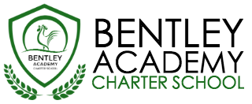
Bentley Academy Charter School
Board of Trustees Meeting
Wednesday, January 27th 2016
6:00pm
At the Bentley School
25 Memorial Drive, Salem MA 01970

Notice is hereby given that the Bentley Academy Charter School Board of Trustees will hold a Board Meeting on Wednesday, January 27, 2016 at 6:00 p.m. at the Bentley School, 25 Memorial Drive, Salem, MA.

6:00 | - Call to Order
6:00-6:05 | - Approval of Minutes (Action Required)
6:05-6:10 | - Meeting Format
6:10-6:15 | - Budget Update
6:15:6:20 | - Head of School Report
6:15 to 6:45 | - Academic Report
6:45: to 7:15 | - School Goals, Draft Accountability Plan, HOS Goals (Action Required)
7:15-7:30 | - Retreat Follow-Up and Timeline
7:30-7:45 | - Process for Selecting Board Members (Action Required)
7:45 | - Adjourn  - Next Meetings: 2.24, 3.23, 4.27, 5.25, 6.22, 8.24

“Know Your Rights Under the Open Meeting Law, M.G.L. c.30A § 18-25 and City Ordinance Sections 2-2028 through 2-2033.”

