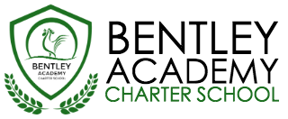
Bentley Academy Charter School
Board of Trustees Meeting
Wednesday, March 8th 2016
8:00pm
At the Bentley School
25 Memorial Drive, Salem MA 01970

Mission: Bentley Academy Charter School prepares all of its students for personal and academic success to get to and through college. Through a combination of high academic standards, data-derived instructional methods, and community supports and partnerships, Bentley Academy Charter School establishes the critical foundation necessary for students to thrive as they advance in their academic careers.

March 3, 2016

Notice is hereby given that the Bentley Academy Charter School Board of Trustees will hold a Board of Trustees Meeting on Tuesday, March 8, 2016 at 8:00 p.m. at the Bentley School, 25 Memorial Drive, Salem, MA. 01970

8:00 | - Call to Order
8:00-8:05 | - Approval of Minutes (Action Required)
8:05-9:00 | - Report and recommendation from restructuring committee (Action Required)
9:00 | - Adjourn  - Next Meetings: 3.23, 4.27, 5.25, 6.22, 8.24

Respectfully submitted by

____________________________
Eileen M. Sacco, Secretary to
Salem School Committee

