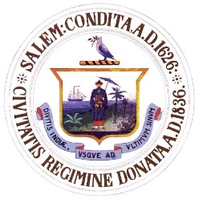
City of Salem, Massachusetts
Department of Open Space
Cemetery – Shade Tree – Open Space
57 Orne Street
Salem, Massachusetts 01970
SeAN Mc CrEA
asst. director of public services

Kimberley Driscoll
Mayor
Telephone: 978-745-0195
Fax: 978-741-7041

NOTICE

CEMETERY COMMISSION MEETING

To: Board of Cemetery Commissioners

Subject: Cemetery Commission Meeting and Agenda

A special meeting of the Cemetery Commission is scheduled for Wednesday, April 19, 2017 at 6:30 pm. It will be held at 120 Washington Street, 3rd Floor, Salem, MA, in the medium conference room.

AGENDA

- Roll call of Board members
- Read Minutes from last meeting
- Unfinished business:
Request for a letter of support to release funds from the Melden Trust Fund
Request for a letter of support to release funds from the Perpetual Care Fund
Request for a letter of support to release funds from the Barnes Fund

- New business:
Request from Christine Lutts, Friends of Greenlawn, for permission to put
Donation envelopes at the Cemetery board.

“Know Your Rights Under the Open Meeting Law M.G.L. c.30A§§18-25 and City ordinance Sections 2-2028 through 2-2033.”

