SUMMARY

The first Citywide Conversation was held at Collins Middle School in Salem on the evening of Tuesday, November 29, 2016. The key goals of the event were the following:
- To introduce the community to the Salem Public Schools Strategic Planning Process
- To invite the community to help shape the future of the district
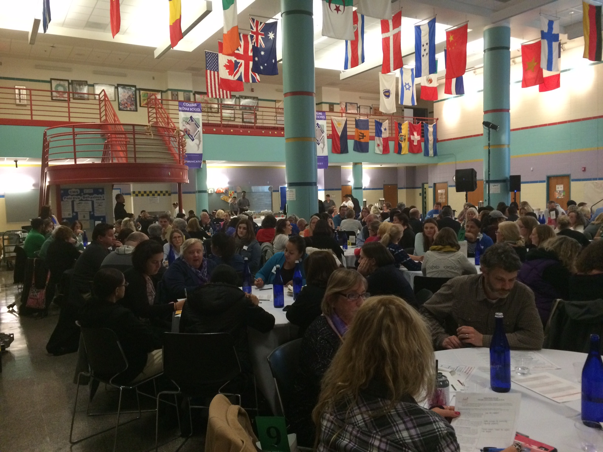
- To bring all of the relevant stakeholders—parents, students, teachers, administrators, business leaders, community partners, elected officials, and citizens—together for meaningful conversations about teaching and learning.

The event opened with comments by Mayor Kim Driscoll, followed by a short video of a TEDx talk by Harvard professor Todd Rose. Superintendent Margarita Ruiz then provided a brief overview of the strategic planning process and the six “Levers for Change,” which was followed by facilitated small group discussions of the levers at each of 26 tables. After the small group discussions, a short video of a talk on the “Seven Survival Skills” by Tony Wagner was shown. In their small groups, attendees then discussed the skills and qualities they feel SPS graduates should have in order to thrive in the 21st century, reflected on positive experiences in the school district, and drafted their own vision statements for the district.

To conclude the event, Superintendent Ruiz reconvened the attendees and announced that the second Citywide Conversation would be held on March 22, 2017. She invited all participants to attend and asked them to encourage their colleagues and friends to attend as well.

OPENING REMARKS BY MAYOR KIM DRISCOLL

Mayor Driscoll opened the event by thanking everyone for attending. She set the stage for a conversation about the future of Salem Public Schools at a critical time in the city’s future, with its 400th anniversary approaching in ten years.

Mayor Driscoll then recognized the elected officials present at the event:
- State Representative Paul Tucker
- Jason Silva (representative from Senator Lovely’s office)
- School Committee:
  - Dr. Brendan Walsh
  - Patrick Schultz
  - Mary Manning
  - Debbie Amaral
  - Kris Wilson
- City councilors:
  - Ward 2 Councilor Heather Famico
  - Ward 5 Councilor Josh Turiel
  - At-large Councilor Tom Furey
  - At-large Councilor Elaine Milo

Mayor Driscoll highlighted that the world is rapidly changing and that young people are the city’s most important investment because they will soon be leading and contributing to this new world.

Mayor Driscoll focused on the fact that, unlike past meetings, the Citywide Conversation is not about turning the schools around or “getting out from under a rock,” but about looking to the future and determining how to make SPS the best it can be for Salem’s youth and the future of Salem. She stressed that Salem has great leaders, teachers, and amazing partnerships. How, she asked, do we leverage all of these stakeholders to best position SPS students for success?

Mayor Driscoll then shared a few key statistics. According to the Massachusetts Business Alliance for Education, 71% of all of the jobs in the Commonwealth will require education beyond high school. Roughly 16% of jobs will require some college, 8% an associate’s degree, 28% a bachelor’s degree. In previous generations, there were places where you could work your whole life, but that scenario rarely exists today. Times have changed and it’s important for us to determine how best to prepare our students—and our city—for success. Everyone has a stake in the future of the school district because youth development is community development.

Mayor Driscoll then introduced a video of a TEDx talk by Harvard Graduate School of Education professor Todd Rose. The video makes the point that there is no such thing as an average learner, and that it’s incumbent upon us to design schools that enable all kinds of minds to develop and all kinds of talents to flourish.

OPENING REMARKS BY SUPERINTENDENT MARGARITA RUIZ

Following the video, Superintendent Ruiz made the connection between Todd Rose’s point not to design education for a mythical “average” student and emphasized the importance of modernizing SPS so that the district can do a better job of meeting all students’ needs and preparing them for success in the 21st century.

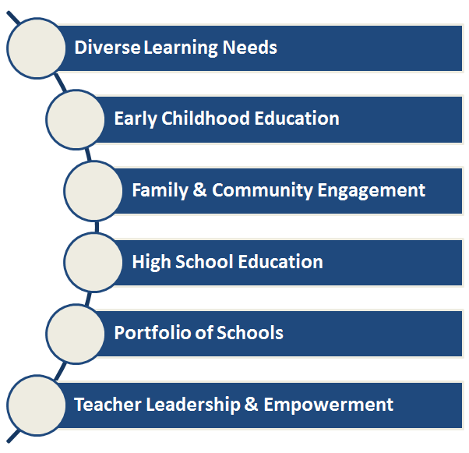
Superintendent Ruiz then described the strategic planning process that began in late spring. She explained that there are six different Work Teams, each tackling a different domain within SPS, or a “lever for change.” The levers for change appear to the right.

Superintendent Ruiz noted that a Steering Committee oversees the work of the Work Teams and will ensure that the contributions of the different Work Teams will ultimately lead to a single unified strategic plan. She then invited participants to discuss their hopes and dreams for Salem Public Schools within the context of the six Levers for Change. Facilitators then kicked off the small table discussions.

SMALL TABLE DISCUSSION OF LEVERS

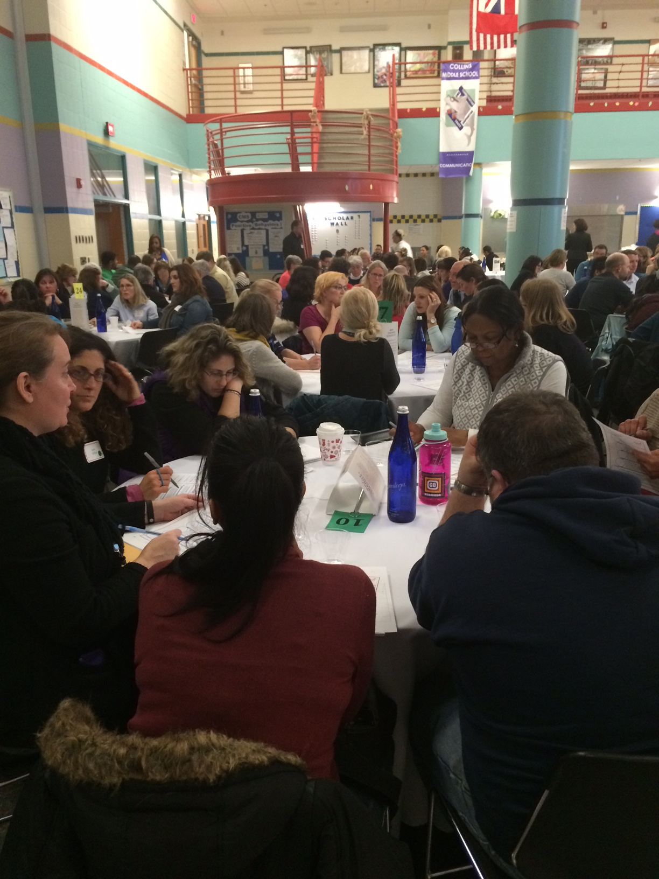
Participants were provided with short descriptions of each of the six Levers for Change, which they were invited to read together at their tables. They were then asked to select three Levers that spoke most directly to their own interests. In summary:

19 tables chose to discuss Diverse Learning Needs
7 tables chose Early Childhood Education
13 chose Family & Community Engagement
10 chose High School Education
4 chose Portfolio of Schools
5 chose Teacher Leadership and Empowerment

Below are summaries of the table conversations that ensued.
Meeting the Diverse Needs of All Learners

Lever Description: Experts remind us that there is no such thing as an average learner. How do we best address the diverse learning needs of all of our students? How do we begin to identify and implement the most innovative approaches to meet those needs in every classroom?

Nineteen tables chose to discuss this Lever. Below are some important themes that emerged. Because the volume of conversation around this topic was so high, we have also included additional notes in bulleted form following the key themes in order to capture the complete picture of these discussions.

Personalization/Competency Based Models
Twelve of the groups discussed the need to personalize learning and/or use competency based models in order to better meet the needs of students. Participants felt that there is a need to customize education since all children learn differently. They did acknowledge that large class sizes make it difficult for teachers to customize instruction in a traditional classroom environment.

Many groups also discussed choice as an important factor in engaging more students, and one group used the Montessori system as an example of an approach that allows students to choose the learning that most interests them. Groups discussed that personalizing instruction will be critical to keeping students engaged, and parents are worried that if education does not feel personal and relevant to their child, the child might lose interest. Another group discussed the need to give students a chance to drive how the content is taught so that it can more effectively meet their learning needs. They noted that, just as students have diverse learning styles, they also have diverse motivations for wanting to learn. Moreover, they said that students must understand how they learn and develop the skills to do so effectively. This effort to personalize education should extend to assessments as well, since not all students can demonstrate their learning in the same manner.

One group discussed the idea that there really is no “average student,” and discussed the notion that every student in the district should have an Individualized Education Plan (IEP), since each child is truly unique. This plan would describe the way that each student learns, and would draw students and their families into the development process.

Groups also discussed a need to focus on the whole child and their holistic goals and interests, rather than a narrow conception of content acquisition.

Two groups talked about Carlton’s competency-based model, praising it for meeting learners where they are and adjusting grade level by mastery and learning needs. They also lauded the Carlton for its commitment to helping students advocate for themselves and their needs, for hewing to progressive values, and for its frequent use of assessments to monitor student progress.
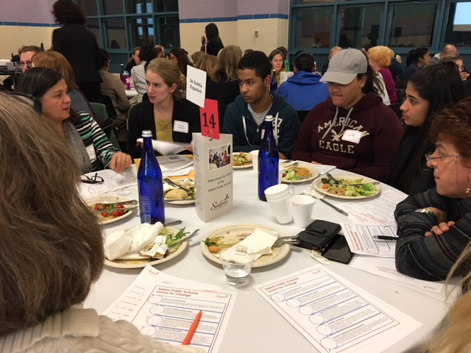

Cultural Competence
Nine of the 19 groups that discussed Diverse Learning Needs also mentioned the importance of cultural competence in order to facilitate stronger partnerships with parents and students. Many of these groups discussed the need for teacher professional development along these lines. A good example of such in the district is the new course for teachers about the Dominican Republic. Other cultures, they said, also needed representation.

Some groups also discussed the need for more diversity in the curriculum so that students of all backgrounds feel that their home cultures are honored as strengths, not liabilities. One group discussed the danger of misinterpreting low English language proficiency as a learning disability. They mentioned dual language immersion as an asset-based approach to language learning. Participants also discussed the need for staff to be representative of the student population. One group shared that people stay in Salem specifically because of its diversity, and another group expressed a desire to bring a more diverse set of voices to the decision-making process.

Other themes that arose regarding Diverse Learning Needs:

Curriculum/Assessment
- Consider portfolio assessment, e.g., demonstrations of learning that go beyond traditional paper-and-pencil tests and honor student preferences
- A more flexible curriculum that offers more options and challenges students
- More curricular coherence across the district, including common outcomes
- Sharing of best practices across the district, and greater use of evidence-based instructional practices
- Greater use in the district of multi-media resources, and leveraging technology effectively, including blended learning
- More service-based learning in order to engage young people in the community
- Additional enrichment programming, such as physical education, music, and art
- Recognition of the importance of play and unstructured time during the school day to allow for student exploration of interests
- Consider co-teaching and looping
- Increase level of rigor in both the classroom and in homework assignments

Parent Engagement and Communication
Staff must gain a deeper understanding of the home cultures of students
- Staff and parents should communicate regularly about a student’s learning needs beginning in Kindergarten
- Recognize that parents may care about their child and his/her schooling, but may not be able to participate in public activities because of home or work circumstances. All forms of participation should be equally valued by school staff
- Homework help would be appreciated, such as that offered by the Horace Mann School, which has free after-school tutoring and homework assistance
- Translations, via technology, could help parents understand their children’s homework in their home language
- Intentional and sustained outreach to families to engage them on their own terms, and help them understand how their children are progressing
- Strengthen the Parent Information Center

Professional Development
- Utilize PD to help teachers better understand the diverse needs of all of their students, potentially leveraging exemplary teachers in the district
- Move beyond building-specific PD to spread expertise across the district
- Utilize specific protocols to give teachers an opportunity to review the practices of other teachers in the district and bring them back to their respective buildings
- Embrace strategies that enable general education teachers to better meet the needs of English Language Learners, students with disabilities, and others within their classrooms. This might include more effective classroom management strategies

Early Intervention/ Wraparound Services
- Recognizing that children often come to school with needs related to challenging family and community conditions, focus on early intervention, particularly as it relates to Kindergarten readiness, and find ways to provide medical and dental care to students, meals and clothing to those in need, and additional emotional and academic supports

Accountability
- Be more consistent about holding students accountable for homework completion
- Reconcile federal and state mandates with the desires of the community to choose more innovative educational models

Student-Teacher Relationships
- Develop stronger student-teacher relationships by fostering personal connections that enable teachers to better know their students. This is especially important in the transition grades.
- Place more than one adult in the classroom, and schedule home visits on a regular basis.
Early Childhood Education

Lever Description: There is now scientific consensus that the early years of life matter greatly to a child’s future success and wellbeing. How can we ensure that all of Salem’s children get a healthy start in life? What does it mean in the 21st century to be ready for school, and what will it take to get every child ready?

Seven tables chose to discuss this Lever. Below are some important themes from their conversations:

Early Intervention/Universal Access/Logistics
Six out of the seven groups who discussed early childhood discussed the importance of universal access to quality early childhood education. Some groups also focused on the need for early intervention for at-risk students, and some groups offered logistical suggestions to enable more children to access these services.

One group used the analogy that early childhood is the foundation of a house on which the rest of a child’s education is built. Therefore, they advocated for universal access for all Salem children to quality early childhood education.

Several groups also expressed that early intervention can help close the gaps that exist among students. Participants noted that there are observable differences between those children who attend pre-K programs and those who do not. Groups also advocated for increased communication between pre-K programs and Kindergarten teachers. They felt that this was a missed opportunity for getting to know their learners better.

Several groups discussed the need for additional transportation to be provided to families so that more are able to take advantage of the early childhood programs. They also discussed the need for more centers in additional locations to serve the growing population. Some groups also suggested a universal preschool center, while others suggested hosting pre-K programs at existing school sites, such as the one at the Bentley School. Another group suggested that the schools make connections with existing preschool programs in Salem, such as Salem Community Preschool. Existing programs such as Pathways and Head Start were also mentioned. Another suggestion was to communicate more with parents, and also to ensure that these young children have access to proper nutrition.

Some noted that half-day preschool programs are not sufficient for working families who may not have the means to pick their child up in the middle of the day. Several groups expressed a desire for full-day programming.

Regarding cost, several groups suggested that universal prekindergarten programming should be available to all children at no cost. Another group mentioned securing outside funding to make this possible.

Project and Play Based
Three of the groups that discussed Early Childhood Education hoped that there would be a focus on play-based and/or project-based learning in these early years. These groups mentioned that play is a crucial learning facilitator for young children, and therefore hoped for additional recess or other play time during the day. There was acknowledgement that time spent outside is also important, and the groups discussed that some of the private preschools that their children had attended had focused on play.

Developmentally Appropriate
Three groups said that early childhood education must be developmentally appropriate for young children. They hoped for an additional focus on child development and assurance that children would not be rushed to learn certain things before they are developmentally ready. One group advocated for a competency-based approach whereby children do not move on until they have mastered certain skills in accordance with their developmental pace.

Skills
Two groups focused on the skills that they would like children to develop during the early childhood years. Both groups focused on the importance of building social skills, and one of the groups also focused on making sure that students know letters and numbers before moving on to kindergarten. This group wanted specific goals to be articulated for early childhood education, ensuring a balance between social and academic skills.
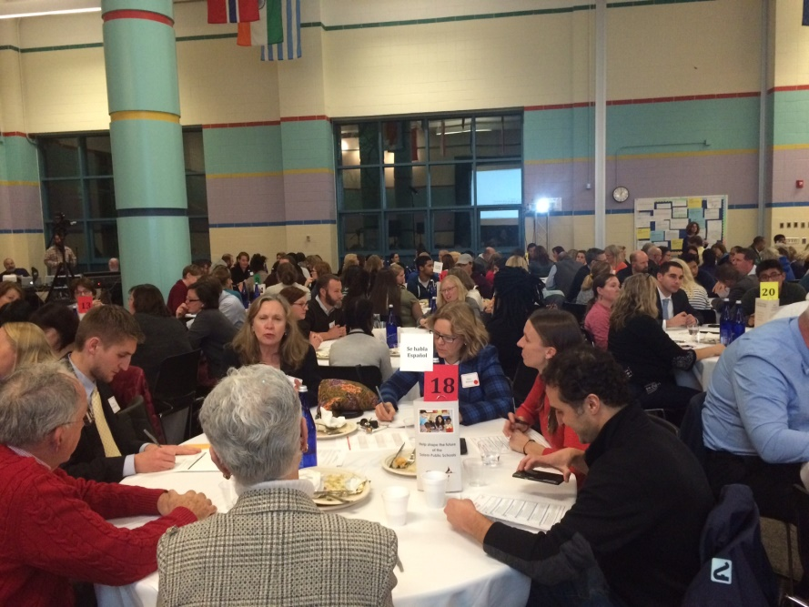
Access to Information
Groups wanted to ensure that all parents are aware of the preschool options that are available, and wanted more access to this information, in addition to what is already available on the website or at the Parent Information Center.

Participants also felt it was important to share more information with families about what Kindergarten readiness truly looks like, and what community resources are available to help them get there.
Family & Community Engagement

Lever Description: Engaging families and the community is central to the success of our schools. What strategies will make every parent feel welcome in our schools? How can educators, parents, and community best join together in partnership? How can we continue to broaden and deepen our formal community partnerships to benefit Salem’s children?
Thirteen tables chose to discuss this Lever. Below are some important themes from their conversations:

Technology
Eight groups discussed the importance of leveraging technology (i.e., posting homework and other resources online, using Dojo and Facebook more frequently, increasing the volume of emails to parents, etc.). Participants pointed out that the SPS website should be updated more frequently and should be more user friendly to encourage parents and families to access the website for information. One participant suggested utilizing daily logs so that parents have more information about what goes on during the day and can better support their children’s learning. Participants shared that they want to be able to access information from the district themselves rather than waiting for it to be pushed out to them. Noting that participation in community events requires time and capital, one participant suggested that SPS should offer an alternative method of participation that requires less face-to-face commitment.

Outreach to Parents
Seven groups noted that there should be more teacher outreach to parents. One participant stated that “teachers need to become more like extended family” and others stressed the importance of consistent communication between teachers and parents (and not just when there is a problem). One participant noted that parents don’t “always want to be the ones that come in and begin the conversations with the teachers,” and several participants pointed out that there should be more parent-teacher conferences during the year. One group said that all schools should be more accessible to families, particularly families without cars, perhaps by offering buses for parents to come to parent/teacher conferences, visiting parents at home, or holding parent/teacher conferences at the YMCA or Boys and Girls Club.

Another group suggested implementing home visits for any family that has not had the opportunity to come to their child’s school. Finally, one participant suggested providing parents with a menu of ways to be involved in their child’s school (i.e., things to do, things to bring, ways to help at home or in the community, etc.).

Communication with Non-English-Speaking Parents
Five groups stressed the importance of improving communication with parents who do not speak English. One participant suggested that more Spanish speakers should be on staff to work with Spanish-speaking families -- bilingual staff need to “be present within all staff at all levels.” Participants also noted that there needs to be a “more intentional connection with the Latino community” and stated that home visits may “help develop teachers’ cultural competence” and build trust.

One group discussed the idea of offering English language classes to parents to help them feel more welcome in the schools and to allow them to develop their English language skills. Participants also suggested having more bilingual students act as translators.

Opportunities for Families to Connect
Three groups pointed out that there should be more opportunities for families to be connected to each other and learn from one another. One participant noted that the schools are diverse, but the parent groups are not. Another participant suggested “partnering new families with existing families to welcome them” and that there should be greater “communication between parent groups in schools” to “share resources and ideas.” To this end, one participant suggested an email list for parents.

Student-to-Student Outreach
Two groups discussed the idea of increasing student outreach to other students. In particular, one group suggested that current students could act as ambassadors to help students who are new to the district.

Community Activities
Two groups emphasized that SPS-sponsored community events (such as the Thanksgiving dinner) have been very worthwhile and successful, and expressed a desire for more events like these. One group noted that community events are not always welcoming for non-English speaking parents, and suggested additional translators for a greater variety of languages at community events.

High School Education

Lever Description: The majority of high schools in America today were built for the industrial era, when a diploma virtually guaranteed a living wage. In today’s changing economy, how can we make sure that all young people have a deeper set of skills and are prepared for the likelihood of multiple careers in a lifetime—some of which haven’t even been invented yet? How can we ensure that every young person in our high schools has a solid plan upon graduation?

Ten tables chose to discuss this Lever. Below are some important themes from their conversations:

Internship Opportunities
Four groups emphasized the importance of adding more internship opportunities for high school students. One participant pointed out that some students don’t take advantage of the available opportunities and it might be helpful to have students encourage their peers to get involved.

Vocational Programs
Three groups discussed the importance of adding more vocational programs. One participant stated that students need to know more about 4-year colleges but also need to know about other options. Career readiness is important for everyone.

Focus on Diversity
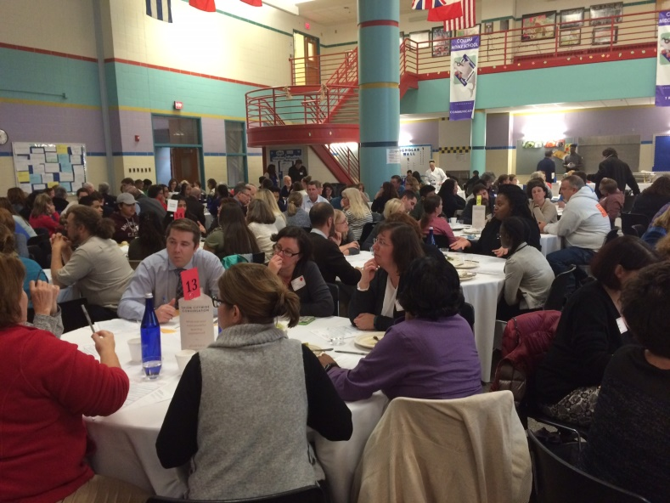
Three groups stressed the importance of a more deliberate focus on diversity. One participant noted that there should be more of an effort to “show appreciation for diversity” and another participant emphasized that the “diversity of students should be represented in the teaching force.” Another participant said that diversity should be “stated explicitly” as a goal. Teachers and staff should be culturally proficient.

Community Service Opportunities
Two groups said they desired more community service opportunities for high school students.

Reorganization of Guidance Department
Two groups recommended that the Guidance Department be reorganized to better meet student needs. One participant noted that guidance counselors have a very large caseload and it might make sense to increase the number of “opportunities in group settings” for students to “get guidance and support.”

More Customizable/Flexible Curriculum
Two groups discussed the need for more customizable and “flexible curriculum.” One participant noted that “creating more pathways for students to take things that interest them...so students know what they want to do in life” is important.

Communication of Options
Two groups emphasized the need for better communication with students about the clubs, extracurricular activities, and internships that are currently available to them.

Student Ownership & Leadership
One group discussed the importance of students taking on leadership roles that allow them to “learn how to take ownership.”

21st Century Skills
One group noted that students need to learn the “skills to live in our world,” such as, “strong communication skills” and the ability to “construct an argument,” as well as creativity and passion.
Portfolio of Schools

Lever Description: What kinds of school designs will best prepare our young people for a future that will be very different from that of previous generations? How can we create learning environments—in and beyond the classroom—that will give all of our children rich, relevant and rigorous experiences that will build their skills and help them develop habits of success?

Four tables chose to discuss this Lever. Below are some important themes from their conversations:

Publicity
Two groups said better publicity is needed about the strengths of SPS and the programming options already in place—and that the diversity of the district is a strength that must be marketed. Some participants expressed being pleasantly surprised when they started looking into district offerings and found that so much is already in place.

The Parent Information Center was discussed as needing to be more proactive about marketing options to the public, and suggested that the district in general should further develop its communications strategies. For example, one member mentioned finding out about the Citywide Conversation from an after-school provider, rather than from the district itself.

Career and Technical Education
One group discussed the need for expanded educational options, particularly at Salem High School. This group noted that college is not the post-high school choice for all students, and expressed a desire for more options to prepare students for a career. The group noted that SHS did have automotive courses, but asked for medical training programs, such as a Certified Nursing Assistant course. The group also discussed the importance of expanding options for gaining hands-on experience, such as internships or apprenticeships in a trade. Some potential areas of focus mentioned: nutrition, life skills, and food preparation.

Post-High School Planning
Another group discussed the need to expand post-high school planning for students. Currently, not all students know what they want to do after high school--making it imperative that students have a plan in place, whether it be attending college, a certification program, or starting a career immediately.

School Choice
One group also discussed the school choice policies and expressed that currently, this process is not transparent. The group wondered if choices distribute the population more evenly, or if using a neighborhood school policy would result in greater inequities.

Partnerships
One group also discussed the richness of the community resources in Salem, such as local businesses or museums, and suggested that the district engage more intentionally with these resources.

Innovation
Another group also discussed options for innovation within the schools. They noted that physical attributes of workplaces are changing, and thus maybe school environments should be physically changing as well. There is also an opportunity to innovation by utilizing technology more effectively.
Teacher Leadership & Empowerment

Lever Description: It is widely understood that teachers are central to the success of our schools. As expectations of what students know and are able to do continue to rise, what do teachers need in order to learn about and implement the most innovative and effective practices? What kinds of opportunities and supports should they receive to grow as professionals?

Five tables chose to discuss this Lever. Below are some important themes from their conversations:

Diversity
Three participants noted the national SEED (Seeking Education Equity & Diversity) program as something for Salem Public Schools to consider.

Peer Learning and Coaching Opportunities for Teachers
One group discussed the idea of having the “best teachers teach other teachers” and giving “teachers time to observe each other.” This group recommended “multiple models and pathways for support within each school and across the district” and discussed the idea of integrating teaching and coaching into “collaborative hybrid roles.” Another participant noted that there are “rock stars” in the district, and it is important to put systems in place for mentoring and sharing across the district. As one participant stated, “It is a lot easier to be helped by a colleague than by [your] boss.”

Teacher Respect and Voice
One participant highlighted the fact that teachers deserve respect, which does not currently always happen. Similarly, another participant noted that teachers should have an “equal voice in identifying structural inequities.”

Teacher Compensation
One group suggested that the district’s compensation system should be restructured so that it is competitive with other urban districts. Another participant recommended that teacher salaries be increased. The idea of unique incentives (e.g., college courses) for teachers was also discussed.

VIDEO & VISION FOR SPS GRADUATES
Following the small table discussions focused on the six Levers for Change, Superintendent Ruiz introduced a video of a talk by noted author and scholar Tony Wagner, who speaks eloquently about the seven most important “survival skills” our children will need in order to thrive in this century and beyond. They are:

- Critical thinking and problem solving
- Collaboration across networks and leading by influence
- Agility and adaptability
- Initiative and entrepreneurship
- Effective oral and written communication
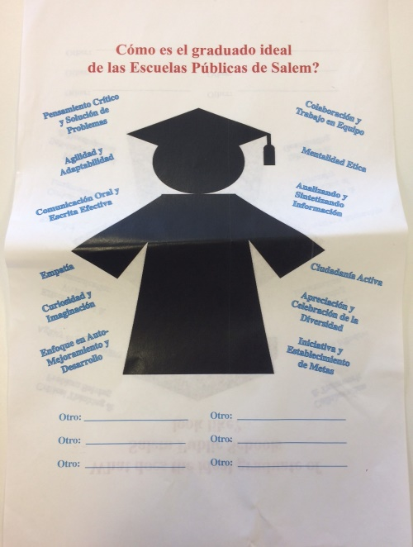
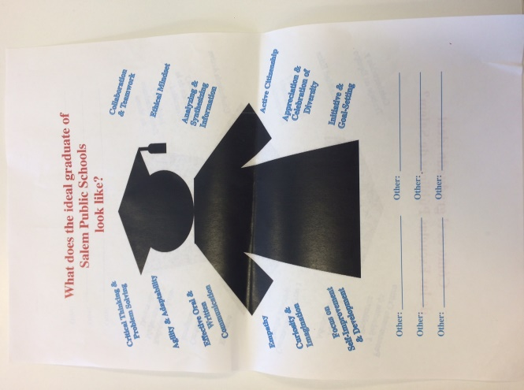
- Accessing and analyzing information
- Curiosity and imagination

At the conclusion of the video, Superintendent Ruiz summarized its core message: “It’s not what you know, but what you do with what you know.” She then asked participants, “What do you think Salem’s young people will need to succeed? What are the skills and qualities that we as a community want a graduate of the Salem Public Schools to possess?” She then invited participants to discuss this question at their tables. Participants were given paper silhouettes of an SPS graduate, along with a list of 21st century skills and qualities. Participants broke into pairs at their tables and selected the top 5 skills they felt were most important. The results of that exercise are summarized in the next section.

SKILLS AND QUALITIES OF AN SPS GRADUATE

In pairs, participants chose which of the 12 skills and qualities most resonated with them. The list of suggested skills and qualities included:
- Agility & Adaptability
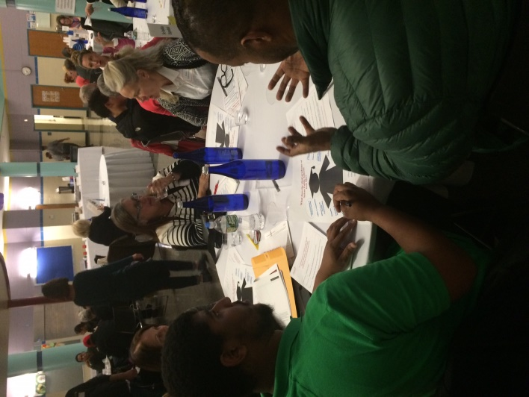
- Effective Oral & Written Communication
- Empathy
- Curiosity & Imagination
- Focus on Self-Improvement & Development
- Collaboration & Teamwork
- Ethical Mindset
- Analyzing & Synthesizing Information
- Active Citizenship
- Appreciation & Celebration of Diversity
- Initiative & Goal-Setting

The graph below shows the number of groups ranking each skill or quality. The top five skills and qualities listed as most important were:
- Critical Thinking and Problem Solving
- Effective Oral and Written Communication
- Collaboration and Teamwork
- Empathy
- Curiosity and Imagination

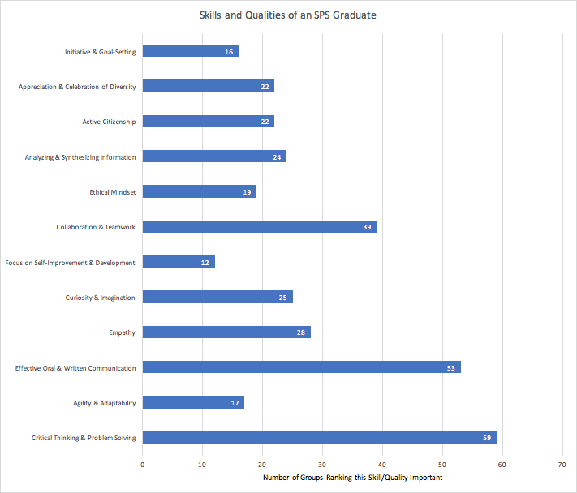

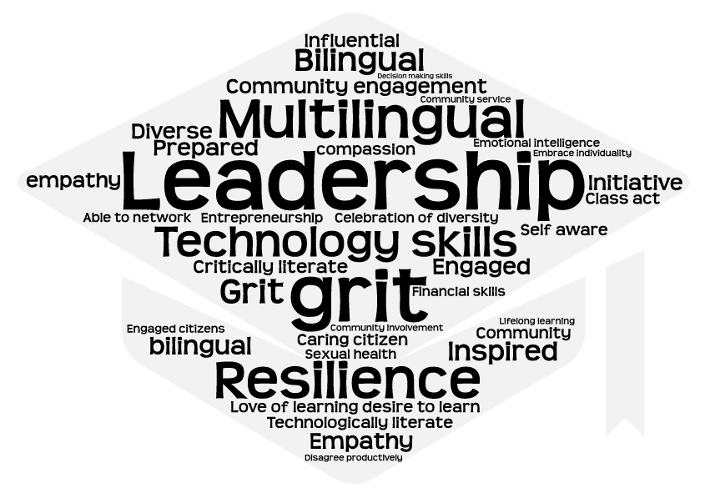
Participants were also able to write in skills and qualities that seemed missing from the list. They are represented in the following graphic.

INTRODUCTION TO VISION EXERCISE
Superintendent Ruiz reconvened the participants and asked them to imagine a 21st century school system that builds the essential skills and qualities that young people will need for success. She reminded participants that one of the findings of her Entry Plan to the School Committee was that the district did not have a compelling vision to guide its work. Since then, she noted, the School Committee created a draft vision statement that would require full vetting by the district and the community. Prior to presenting the draft, the Superintendent invited participants to focus on what they believe to be the ideal vision for the Salem Public Schools.

To prepare participants for this exercise, Superintendent Ruiz provided the following definition of a vision statement: “A vision is an expression of our deepest aspirations for our future and for our children.” She then provided the following examples of vision statements:
- “To put a man on the moon in ten years”—John F. Kennedy
- “To provide access to the world’s information in one click.” –Google
- “All learners believe in their power to embrace learning, to excel, and to own their future.” –Albemarle County Public Schools, Charlottesville, VA

The Superintendent asked: “What do we want to be able to say about our schools ten years from now at Salem’s 400th anniversary?” She emphasized that a strong vision would serve as SPS’s inspiration, compass, and guiding light, keeping the city and district moving in the right direction. Superintendent Ruiz then introduced the next series of small table conversations, consisting of three parts:
- Positive experiences: Participants take turns reflecting on a positive experience that their child, or a child they know, has recently had in the Salem Public Schools.
- Vision crafting: Each table will brainstorm and craft its own vision statement for Salem Public Schools, and will then write this vision on the “Vision Wall” mural paper.
- Feedback on draft vision statement: Participants will then be given a card with the vision statement that the School Committee drafted (“All students prepared to achieve, inspired to learn”) and will be asked several questions related to this draft vision statement.

POSITIVE EXPERIENCES

Still at their small tables, participants were asked to respond to the following prompt: “Reflect on a positive experience that your child, or a child you know, has recently had in the Salem Public Schools.” It was acknowledged that there are challenges in the school district, but that the purpose of this particular exercise was to focus on the positive experiences within SPS so as to stimulate discussion of people’s greatest aspirations for the district. Below is a sample of some of the participants’ responses:

- One participant said that his/her two children started at SPS last year with very little English and have learned a lot, and have earned honors in algebra, music, and biology
- A couple of participants highlighted the Saltonstall Stew Day, an event in which everyone brings something & they make a big stew together on the day before Thanksgiving
- One participant talked about her child participating in an internship at Peabody Essex Museum
- One participant said that he/she can think of many different examples of students helping each other and thinking about others
- Several participants recalled specific art or science projects that their children did that were particularly rewarding
- One participant noted that her child loved Nature’s Classroom as a positive experience outside of the classroom
- A Salem Public Schools teacher who was a graduate of Salem High School noted that her experience was positive, and inspired her to continue to be involved in SPS as an adult
- One former student shared that he had a difficult time in school, but his teachers never gave up on him and ensured that he graduated
- A participant shared that the positive school culture at Collins Middle School has engaged students who were previously marginalized
- One participant shared that her son had the opportunity to have an internship, which then opened more doors for him
- A student shared that she met a Hispanic staff member, and thought “Oh my god! Hispanic people work here!” and was inspired to take more difficult classes as a result
- One participant shared that they moved to Salem for the inclusion and diversity that it offers
- One participant shared that the band program boosted her daughter’s confidence
- Many people shared experiences that their children had in theater and musical productions that led to increased engagement and joy

CRAFTING A VISION FOR SALEM PUBLIC SCHOOLS

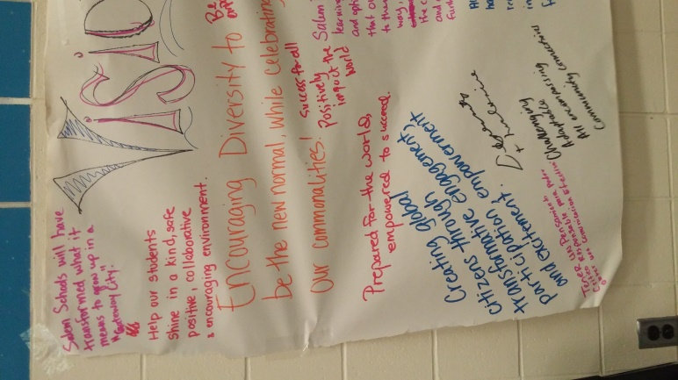
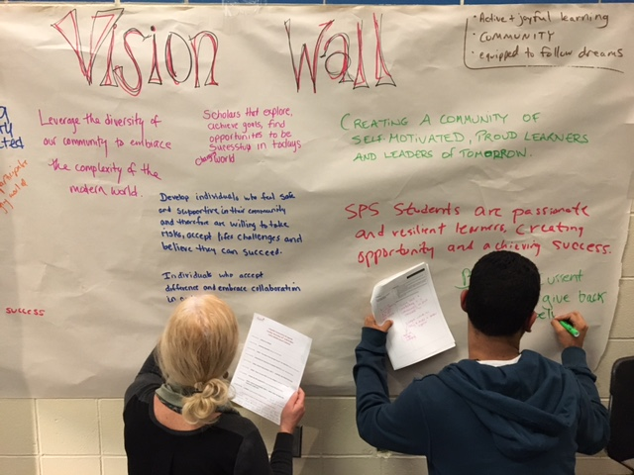
Participants shared their ideas for a vision in their small groups, and then posted them on a visioning wall, and on individual feedback forms. Photos of the visioning walls are included below, and the graphic represents words and phrases that participants shared on their individual forms as being important to include in the SPS vision statement.
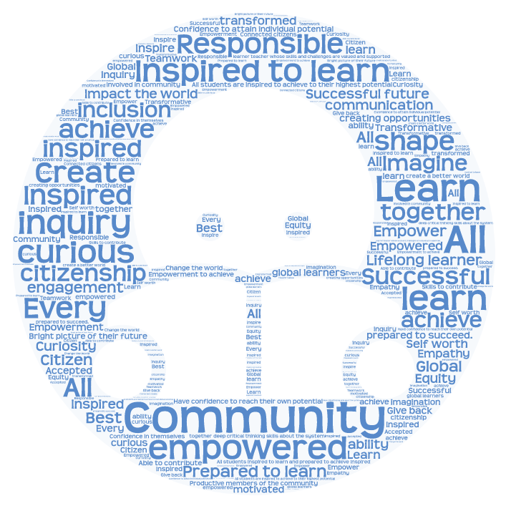

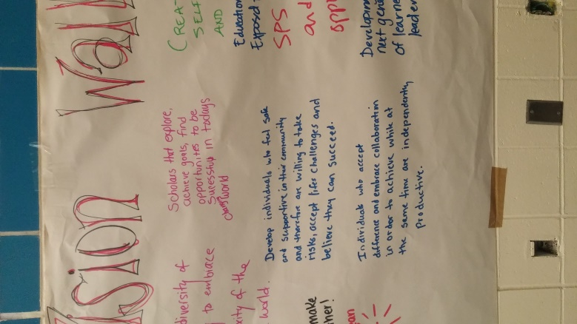

Participants noted that, when finalized, it is imperative that the vision be translated to other languages so that everyone in the community is on the same page.

FEEDBACK ON DRAFT VISION

Participants were given the vision statement that the School Committee drafted and were asked to answer the following questions. We received 134 completed surveys.
- How inspiring is this vision statement? (That is, does it give you chills because it inspires, moves, maybe even scares you?) On a scale from 1 to 5, with 1 being “Not at all inspiring” and 5 being “Extremely inspiring,” the average response was 2.7.
- How much does this vision statement compel you to be involved in making it a reality? On a scale from 1 to 5, with 1 being “Not at all” and 5 being “Extremely,” the average response was 2.9.
- Are there certain key words or phrases you’d like to see included in the vision statement? Responses to this question are reflected in the graphic on the previous page.

CLOSING REMARKS

Following the small table discussions, Superintendent Ruiz made closing remarks. First, she asked for several volunteers to offer one word to describe their feelings about the future of the school district following the night’s discussions. The words given were, “inspired,” “excited,” “optimistic,”, “dedicated,” and “hopeful.”

Superintendent Ruiz then thanked participants for attending and engaging in the conversation. She emphasized that this will be OUR strategic plan in our district in our city. She said that a report to the community on some of the key findings and takeaways from the night’s conversations would be ready in the next month or so.

Participants were then asked to mark their calendars for the second Citywide Conversation on March 22nd, 2017, to continue discussions about the future of SPS. They were also asked to fill out an exit card before leaving, and were encouraged to email superintendent@salemk12.org with any feedback that they were not able to share at tonight’s event.

Superintendent Ruiz thanked the small table facilitators; SPS staff including Chief of Communications Kelley Rice and Executive Assistant Mindy Marino; New Profit staff; the translators; and the babysitters. She told attendees that the night gave her an “amazing sense of hope” that the community is on its way to helping SPS become one of the premier school districts in the Commonwealth.

EXIT SURVEY DATA
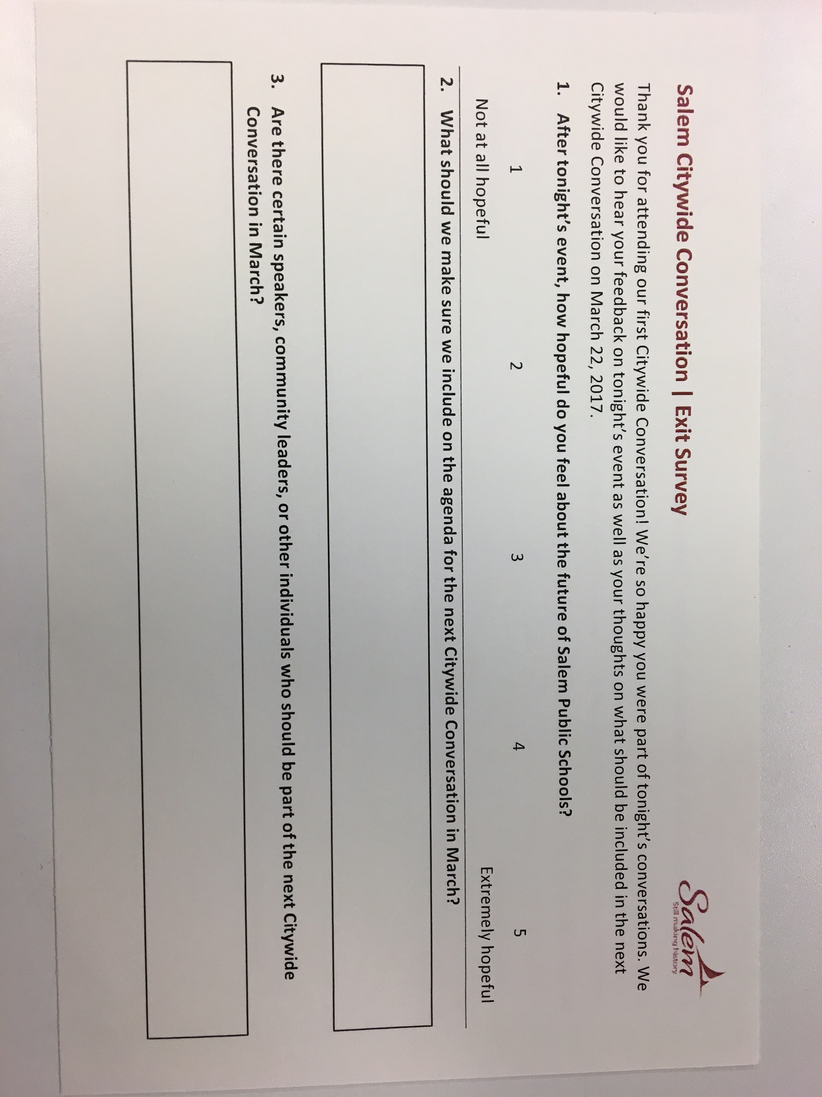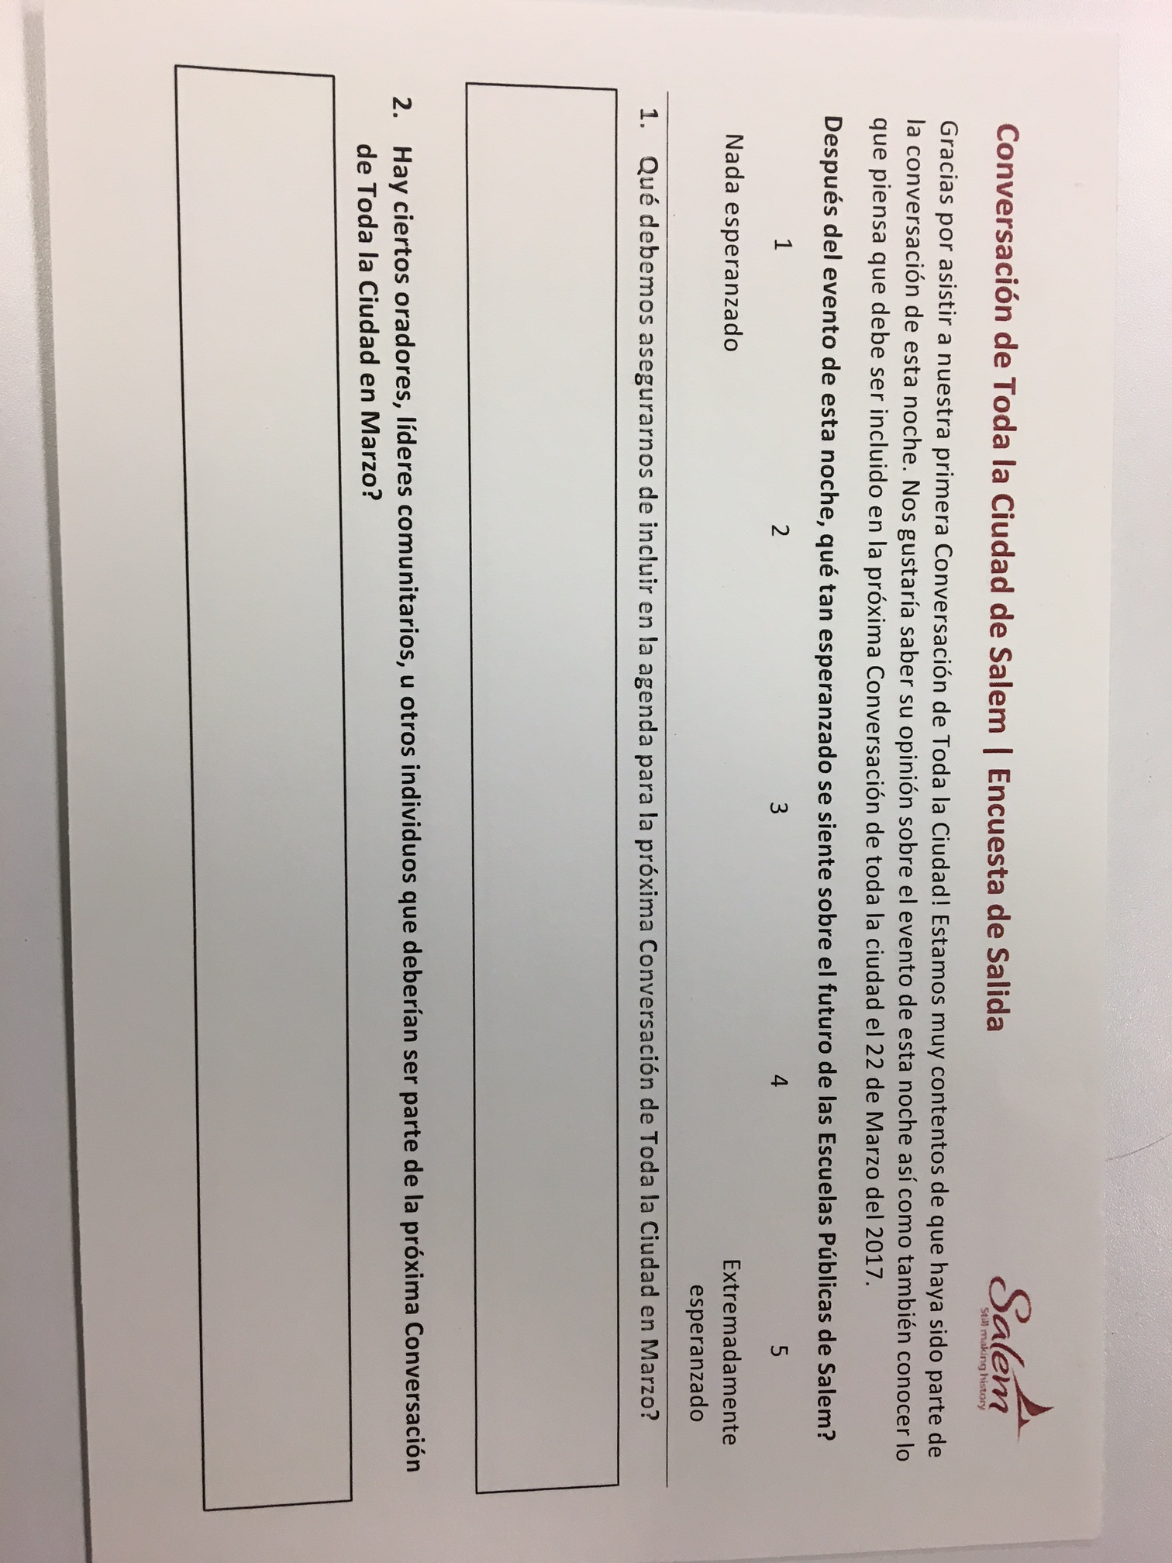
Participants filled out exit surveys before leaving the event, and we received 131 completed surveys. One survey question asked participants, “After tonight’s event, how hopeful do you feel about the future of SPS?” Participants were asked to circle a number from 1 to 5, with 1 being “Not at all hopeful” and 5 being “Extremely hopeful.” The average response to this question was 4.35.

The exit survey also asked, “What should we make sure we include on the agenda for the next Citywide Conversation in March?” Some key themes that appeared in the responses to this question are below:
- Include student voice: 20 respondents
- Update on progress made in different work teams: 11 respondents
- Increase diversity of attendance at the next Citywide Conversation: 11 respondents
- Include more local business owners and community partners: 9 respondents
- Include a synopsis or summary of tonight’s event: 8 respondents
- Include more teacher perspectives: 7 respondents
- Steps that parents and the community can take to engage in the strategic planning process: 5 respondents

