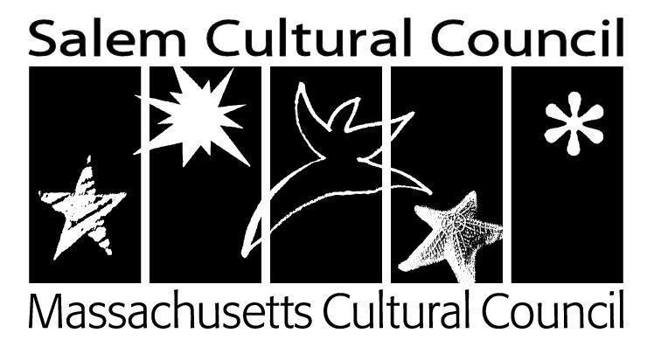
Notice of Public Meeting
Salem Cultural Council
7pm, Thursday, May 24, 2018 (Amended Date)
Old Town Hall, 32 Derby Square, Salem, MA 01970

Agenda

- Approval of March minutes

- FY19 Grant Cycle
    - Priorities
    - Community Engagement

- FY18 Grantees
    - Marketing Support for Grantees
    - Open Items from FY18 (and FY17) Grantees/Reimbursements

- Community Survey
    - Review Examples
    - Draft Questions We Want Answered
    - Distribution Strategy

- Local Fundraising Idea Brainstorm

- Open Recruitment for New Members

- Other/new business

_________________________________________
Courtney Porcella

May 14, 2018

Know Your Rights Under the Open Meeting Law, M.G.L. c. 30A& 18-25, and City Ordinance Sections 2-2028 through 2-2033

