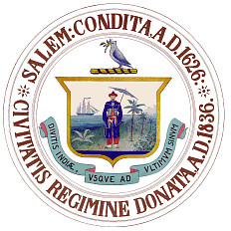
Salem Public Art Commission
120 Washington Street, Salem, Massachusetts 09170
(978) 619-5685 Fax (978) 740-0404

Kimberley Driscoll
Mayor

Meeting Cancellation Notice

You are hereby notified that the Public Art Commission regularly scheduled meeting on Tuesday, June 21, 2016 at City Hall Annex, Room 313,
120 Washington Street, has been cancelled due to a lack of agenda items.

Deborah Greel
Public Art Planner

