March 28, 2016
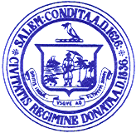

Personnel Subcommittee Meetings

Notice is hereby given that the Salem School Committee Personnel Subcommittee has scheduled the following meetings for the purpose of negotiating with the Salem Teachers Union. The meeting will be held at the Collins Middle School:

Wednesday, March 30, 2016 at 12:30 p.m.
Thursday, March 31, 2016 at 12:30 p.m.

Agenda

12:30 p.m.- Collective Bargaining – Teachers Union Negotiations relative to Collins Middle School Extended Learrning Time

Respectfully submitted by:

___________________________
Eileen M. Sacco, Secretary to the
Salem School Committee

