April 21, 2016
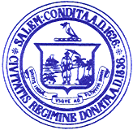

Personnel Subcommittee Meetings

Notice is hereby given that the Salem School Committee Personnel Subcommittee has scheduled a meeting on Monday, April 25 2016 for the purpose of negotiating with the Salem Teachers Union. The meeting will be held at the Collins Middle School.

Agenda

3:00 p.m.- Internal Meeting for Negotiations Strategies
4:00 p.m. – Negotiations with Salem Teachers Union

Respectfully submitted by:

___________________________
Eileen M. Sacco, Secretary to the
Salem School Committee

