March 31, 2016
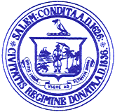

Personnel Subcommittee Meetings

Notice is hereby given that the Salem School Committee Personnel Subcommittee has scheduled a meeting on Tuesday, April 4, 2016 for the purpose of negotiating with the Salem Teachers Union. The meeting will be held at the Collins Middle School.

Agenda

4:00 p.m.- Collective Bargaining – Teachers Union Negotiations

Respectfully submitted by:

___________________________
Eileen M. Sacco, Secretary to the
Salem School Committee

