May 12, 2016
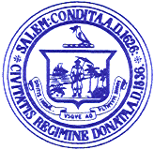

Personnel Subcommittee Meetings

Notice is hereby given that the Salem School Committee Personnel Subcommittee has scheduled a meeting on Thursday, May 19, 2016 for the purpose of negotiating with the Salem Teachers Union. The meeting will be held at the Collins Middle School.

Agenda

3:00 p.m.- Internal Meeting for Negotiations Strategies

Respectfully submitted by:

___________________________
Eileen M. Sacco, Secretary to the
Salem School Committee

