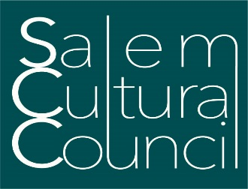

Notice of Public Meeting
Salem Cultural Council
Tuesday, November 26, 2019, 6:00pm
City Hall Annex, 98 Washington Street, Salem MA
3rd Floor Conference Room

Agenda

- Approval of October Meeting Minutes

- FY20 Grant Cycle
  - Grant applicant review and discussion
  - Voting decisions

- Open Items from FY19 Cycle
  - Update on unused funds, final reports

- Any Other Business

Liz Polay-Wettengel, Council Chair
SalemCulturalCouncil@Salem.com

Julie Barry, Senior Planner of Arts & Culture and Council Staff Representative jbarry@salem.com

Know your rights under the Open Meeting Law M.G.L. c. 30A §§18-25 &
City Ordinance Sections 2-2028 through 2-2033.

