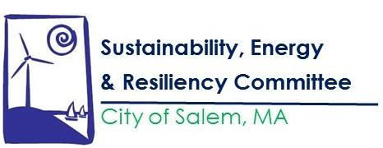

The SERC Committee meeting scheduled for December 18, 2019 at 6:30PM in the City Hall Annex has been cancelled. The next meeting will be January 22, 2020. Happy Holidays to everyone and see you in the next year.

This Photo by Unknown Author is licensed under CC BY

Know Your Rights Under the Open Meeting Law, M.G.L. c. 39 §23B, and City Ordinance Sections 2-2028 through 2-2033. Please contact Jenna Ide at jide@salem.com or 978-619-5699 for more information.

