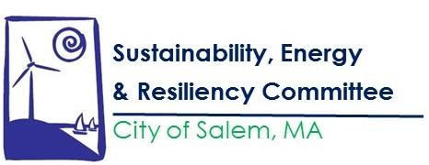

The SERC meeting scheduled for March 25, 2020 at 6:30PM in the City Hall Annex has been cancelled. The next meeting is tentatively scheduled for April 22, 2020. We will keep you updated.

Know Your Rights Under the Open Meeting Law, M.G.L. c. 39 §23B, and City Ordinance Sections 2-2028 through 2-2033. Please contact Jenna Ide at jide@salem.com or 978-619-5699 for more information.

Persons requiring auxiliary aids and services for effective communication such as sign language interpreter, an assistive listening device, or print material in digital format or a reasonable modification in programs, services, policies, or activities, may contact the City of Salem ADA Coordinator as soon as possible and no less than 2 business days before the meeting, program, or event.

